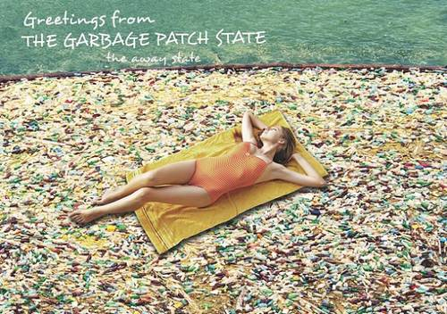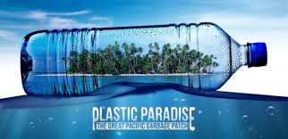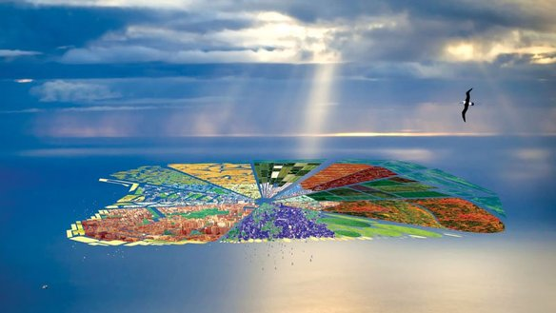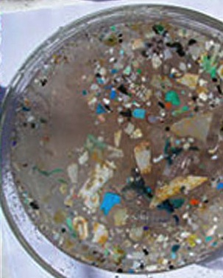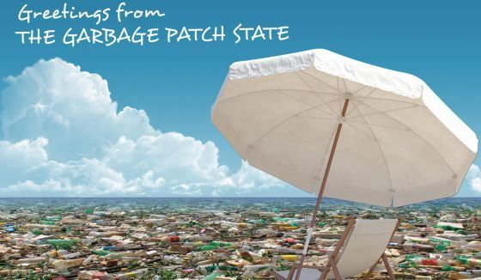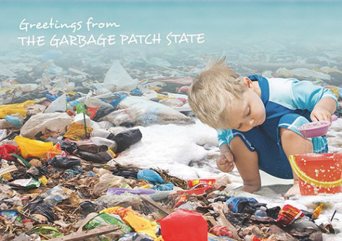

### Visit on of our many “patch” locations

**Visitor Services**, Sightseeing, **Water Sport Attractions**, & Dinning

Welcome to Garbage

Island

## Creation of the Island

Garbage Island also known as The Great Pacific Ocean Patch has had a treacherous history. The United States National Oceanic and Atmospheric Administration first discovered it in 1988. Since then this island has been expanding with your help. It is home of more than 316,800 pieces of plastic per square kilometer. With a great view of human debris it is said to have the best view in all of the North Pacific Ocean. This island is 20 million square kilometers of pure greatness. Book your flight today and spend an unforgettable vacation here at our one and only human made Garbage Island.

123 North Pacific Subtropical Gyre Center  
North Pacific, unknown 123456  
garbageislandtours.com

## Relax &

## Get Pampered

Let’s Talk Trash

* Receive a discount when you book your flight today with Debris airlines.
* Stay at our luxuries Pliant Hotel that includes room service, ocean view, and an indoor pool.
* Other attractions include: swimming with plastic bound dolphins, parasailing with our one of a kind plastic eating birds, and scuba diving with our various debris eating fish.
* plastic region, most originating from the eastern seaboard. In most cases, the buoys reached the plastic patch in less than 60 days. One surprising conclusion of the study found the concentration of plastic in the North Atlantic has remained fairly steady during the past 22 years despite a five-fold increase in global plastic production and a four-fold increase in the amount of plastic the U.S. discards. No one knows how long plastic stays in the ocean or where most of it ultimately will end up. Sea animals such as birds and turtles often consume plastic, sometimes carrying it to land.
* Unfortunately, as beneficial as a cleanup would be to the environment and the local ecosystems, no group has yet been able to come up with a feasible plan that would not do more harm than good; most believe that cleaning up the patch is simply too big of a job. The only thing we can do is prevent it from getting larger.

Family Fun!

* Sightseeing
* Water Gyers
* Extravagant meals
* Top quality

## Enjoy our World Famous Plastic Soup

-Jacques YvesCousteau

“Water and air, the two essential fluids on which all life depends, have become global garbage cans.”

* The Great Pacific Garbage Patch is located in a high-pressure area between the states of Hawaii and California. This area is in the middle of the North Pacific Subtropical Gyre. An ocean gyre is a circular ocean current formed by the Earth’s wind patterns and the forces created by the rotation of the planet. The motion of the gyre prevents garbage and other materials from escaping. The amount of material in the Great Pacific Garbage Patch accumulates because much of it is not biodegradable. As the human population continues to grow and expand so will Garbage Island.
* This phenomenon was first predicted in the late 1980′s, and now “Garbage Island” has become a reality. However to determine where the plastic is coming from, researchers used data from more than 1,600 satellite-tracked drifting buoys deployed between 1989 and 2009 to map surface currents in the region. More than 100 buys through the Atlantic